Investment Portfolio Project
Due: The day you come back from break
40 Points

For this project, you will be creating an investment portfolio for yourself at the assigned age. You must choose at least 4 ways to distribute your investments. Ex: Stocks, bonds, retirement plan, cash, savings, etc. The investments must be from the list of those studied in class and reflect responsible risk taking with rationales.

Inside your folder, you will cut and paste at least 5 paragraphs. You are also welcome to handwrite each component. A photo is required to correlate with each paragraph in addition to a photo of yourself in paragraph #1.

Paragraph 1
- Your first paragraph will contain a brief bio of where you see yourself at that particular age. This can be career and personal. You will then describe your investment approach which should be influenced by the age you drew out of the jar in addition to a photo of yourself. (Black and white is okay. School photos are okay too!)

Paragraphs 2-5 (+):
- Define the investment
- Describe why you chose the investment for that age
- Label the investment as “risky”, “moderate”, or “low
- A photo that correlates to that investment choice

Pie Chart
You will also create a pie chart either by hand or neatly drawn that displays the dispersion of your investments. Your chart should display percentages and add to 100.
EX. Of a Pie Chart:
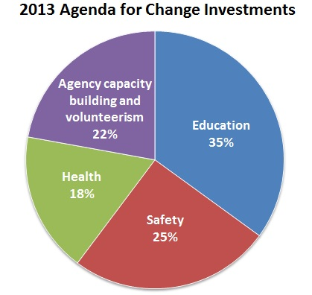

Your project should look creative and reflect your personal style! Including graphics, colors, and photos!

Rubric:
5 paragraphs that contain all of the required information-25 Points
Project is neat, contains some color, and is in a folder with correlating photos-10 Points
Pie Chart-5 Points

Assigned Age:
Brainstorming:

